Shell Scripting on hands Practice

**What is Shell Script:**

In linux or some other distributed versions of the linux the scripts in them become commands in Shells like Bash, korn, etc. These Shells support programming construct in linux and its versions.

* To execute the scripts, I used Bash Shell Online (GNU Bash v4.4).

Let’s look at the GNU Bash terminal in chrome,

Link follows here: <https://www.tutorialspoint.com/execute_bash_online.php>

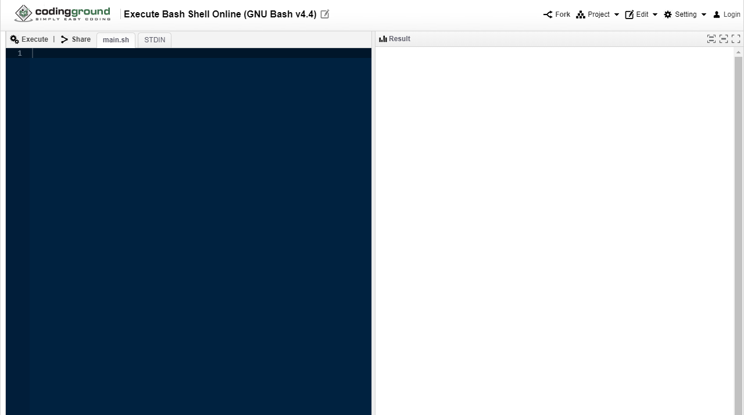

The virtual linux terminal in chrome looks like this:

Link follows here: <https://bellard.org/jslinux/vm.html?url=https://bellard.org/jslinux/buildroot-x86.cfg>

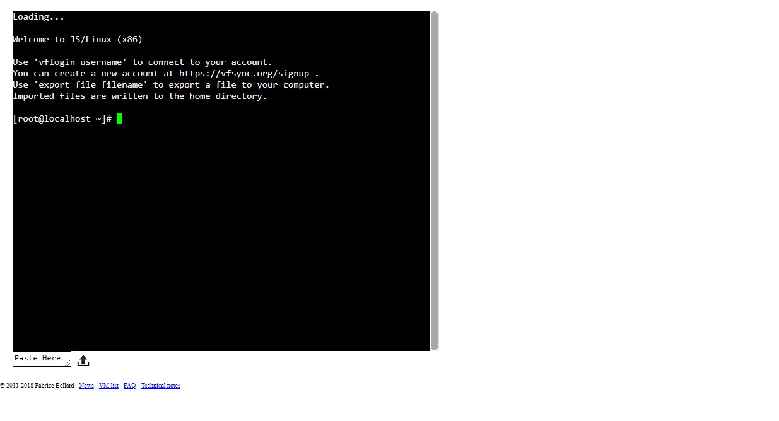

* Let’s look at the name of the Shell in the above virtual BASH terminal by using “echo $SHELL” command:

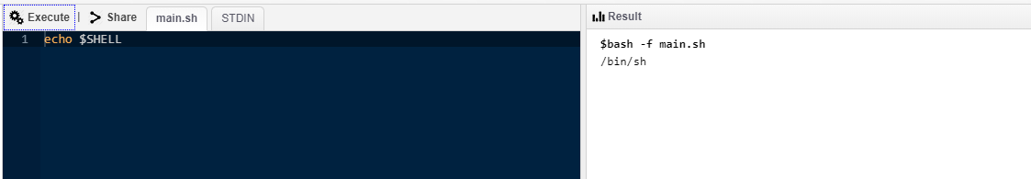

* Let’s try printing some hello world in the shell using ‘echo “Hello world!” ‘command:

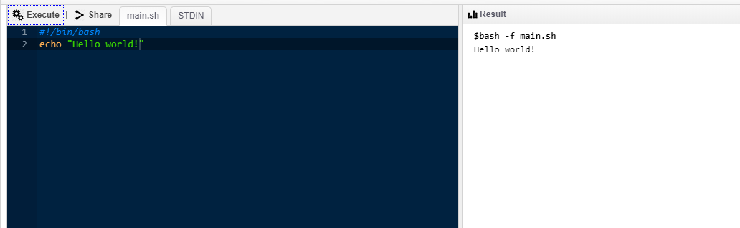

**Note**: Here every line of script starts with #! /bin/bash to pass instruction to the program.

* Comments in scripting in any of the Shells should start with “#” hash:

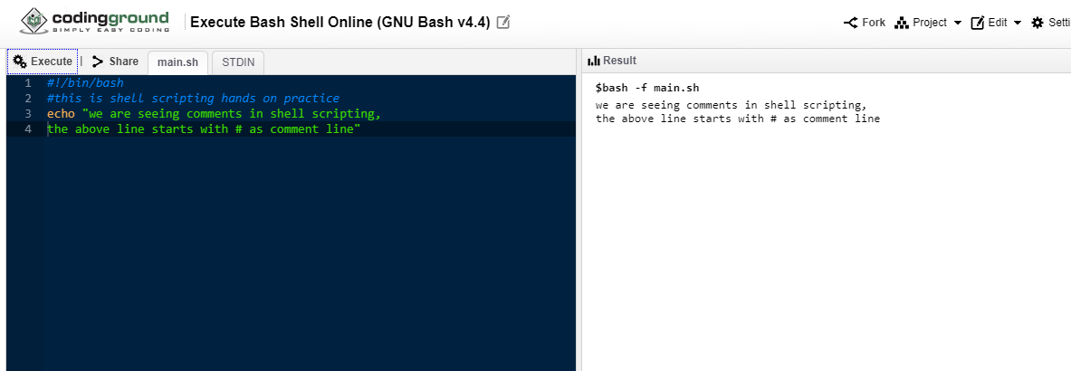

**Variables in Shell scripting:**

Variables in here are scalar variables, as only one value can be assigned to the variable at a time.

A-Z (or) a-z (or) 0-9 (or) _

Valid usage of variables: _var; TOKEN1; Var_2

Let’s assign some variables and try to print them

NAME=” madhuhaas”

Number=10

To access the variables, we use’$’ Infront of the variable name, like “echo $NAME”:

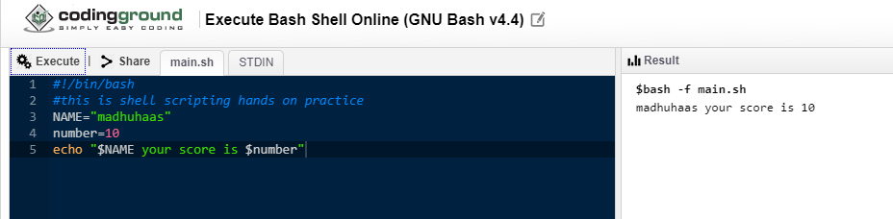

*Read only variable*: the variable cant be changed after it is set as read only

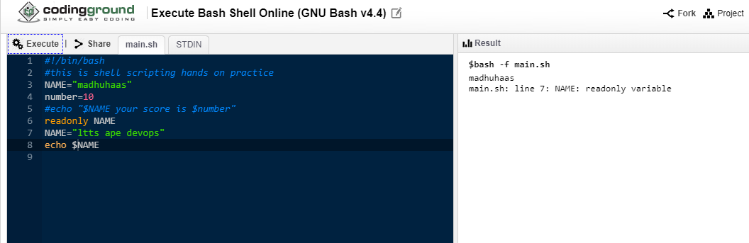

*Unsetting the variable* -deletes or removes the variable, we can see that number variable is not printed in the output:

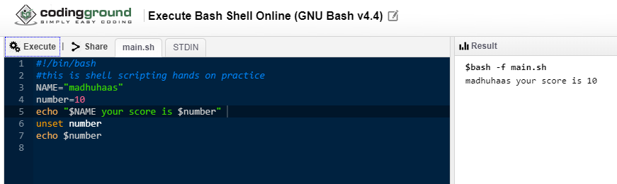

*Troubleshooting a Script*: ‘bash <filename> ‘command executes the script file in linux/Unix terminal

But ‘bash -x <filename>’ command make us to expand the shell with script:

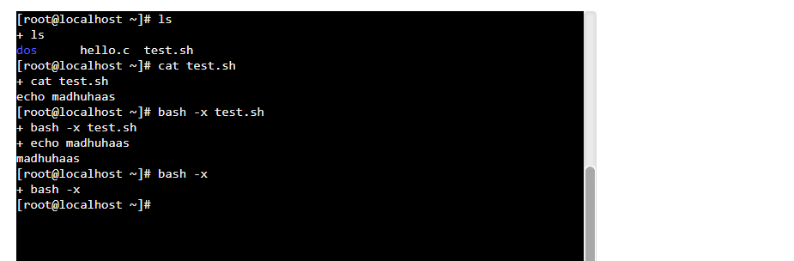

*Steps to write and execute a Script in linux/Unix terminal*:

Create a file; write some commands using echo command; save the file using ‘chmod +x <filename>’ command; run the file using ‘. /<filename>’ command

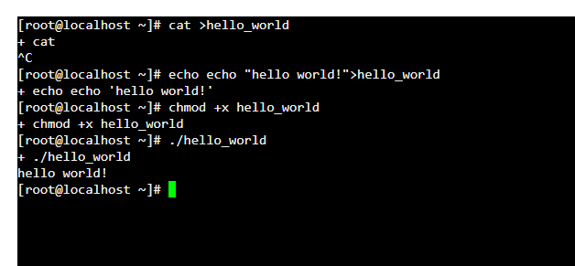

*Passing Parameters in shell scripting*:

To pass the parameters in the shell script, we use ‘read’ command in the script followed by the variable name.

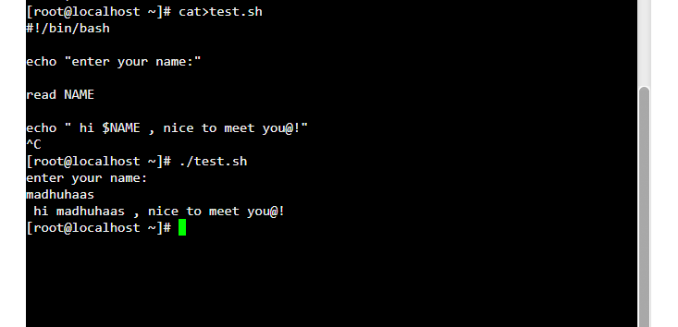

*Sourcing a config file in shell scripting*:

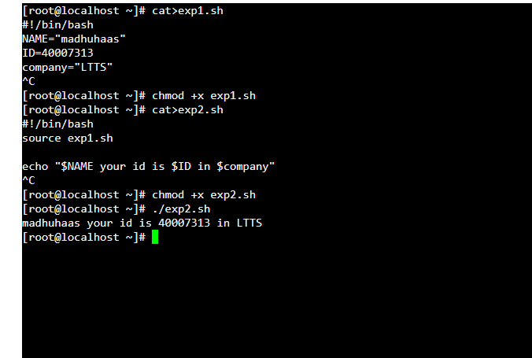

*Getopts options in shell scripting*:

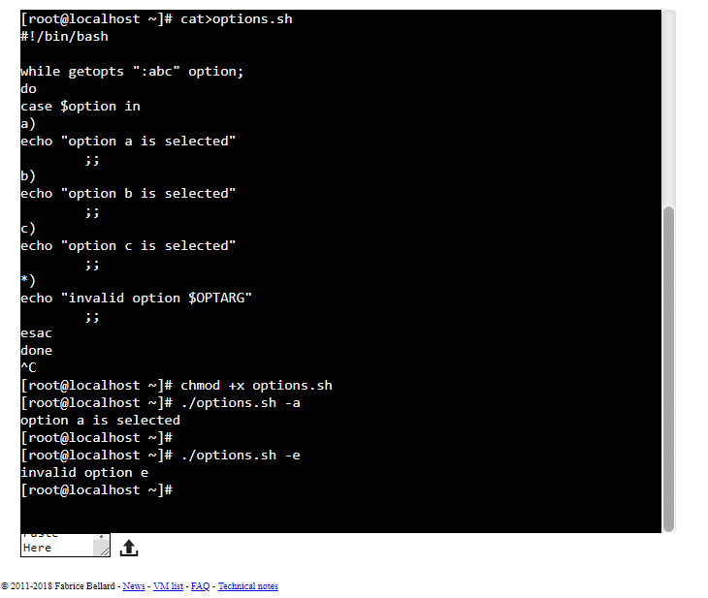

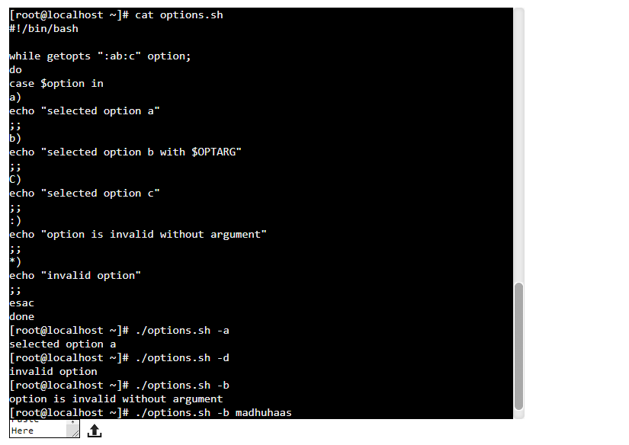

*If then else in shell Scripting*:

(to be continued…………………………….)